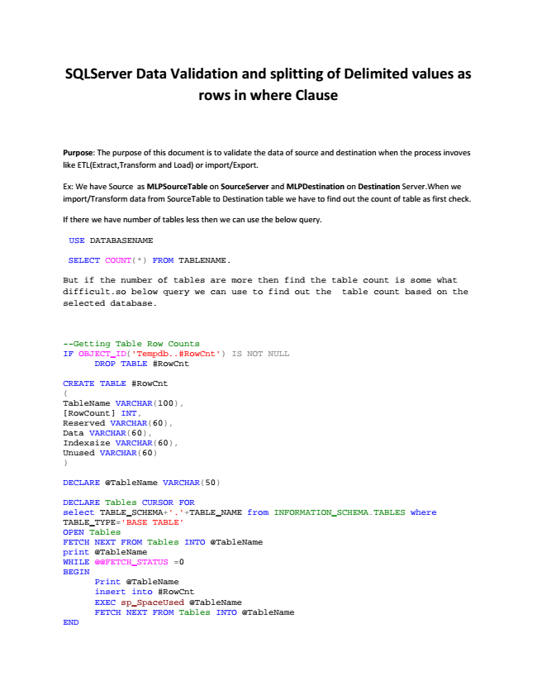

**SQLServer Data Validation and splitting of Delimited values as rows in where Clause**

Purpose: The purpose of this document is to validate the data of source and destination when the process invoves like ETL(Extract,Transform and Load) or import/Export.

Ex: We have Source as MLPSourceTable on SourceServer and MLPDestination on Destination Server.When we import/Transform data from SourceTable to Destination table we have to find out the count of table as first check.

If there we have number of tables less then we can use the below query.

USE DATABASENAME

SELECT COUNT(*) FROM TABLENAME.

But if the number of tables are more then find the table count is some what difficult.so below query we can use to find out the table count based on the selected database.

--Getting Table Row Counts IF OBJECT_ID('Tempdb..#RowCnt') IS NOT NULL

DROP TABLE #RowCnt

CREATE TABLE #RowCnt ( TableName VARCHAR(100), [RowCount] INT, Reserved VARCHAR(60), Data VARCHAR(60), Indexsize VARCHAR(60), Unused VARCHAR(60) )

DECLARE @TableName VARCHAR(50)

DECLARE Tables CURSOR FOR select TABLE_SCHEMA+'.'+TABLE_NAME from INFORMATION_SCHEMA.TABLES where TABLE_TYPE='BASE TABLE' OPEN Tables FETCH NEXT FROM Tables INTO @TableName print @TableName WHILE @@FETCH_STATUS =0 BEGIN

Print @TableName insert into #RowCnt EXEC sp_SpaceUsed @TableName FETCH NEXT FROM Tables INTO @TableName END

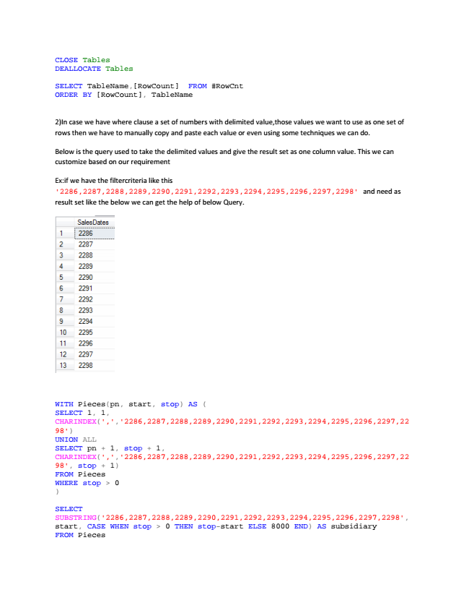

CLOSE Tables DEALLOCATE Tables

SELECT TableName,[RowCount] FROM #RowCnt ORDER BY [RowCount], TableName

2)In case we have where clause a set of numbers with delimited value,those values we want to use as one set of rows then we have to manually copy and paste each value or even using some techniques we can do.

Below is the query used to take the delimited values and give the result set as one column value. This we can customize based on our requirement

Ex:if we have the filtercriteria like this '2286,2287,2288,2289,2290,2291,2292,2293,2294,2295,2296,2297,2298' and need as result set like the below we can get the help of below Query.

WITH Pieces(pn, start, stop) AS ( SELECT 1, 1, CHARINDEX(',','2286,2287,2288,2289,2290,2291,2292,2293,2294,2295,2296,2297,22 98') UNION ALL SELECT pn + 1, stop + 1, CHARINDEX(',','2286,2287,2288,2289,2290,2291,2292,2293,2294,2295,2296,2297,22 98', stop + 1) FROM Pieces WHERE stop > 0 )

SELECT SUBSTRING('2286,2287,2288,2289,2290,2291,2292,2293,2294,2295,2296,2297,2298', start, CASE WHEN stop > 0 THEN stop-start ELSE 8000 END) AS subsidiary FROM Pieces